**In Class Exercise – Interface as a Reference**

You are required to implement a pizza program based on the UML diagram below:

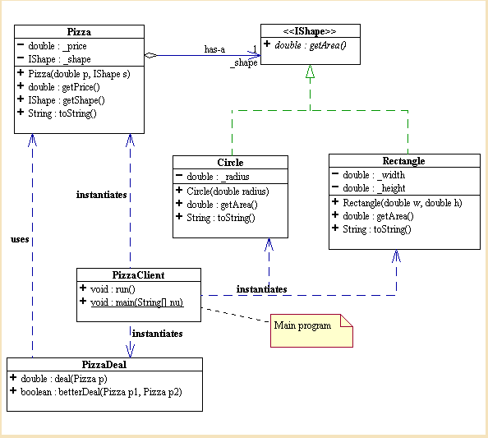

1. Write the Interface IShape
2. Write the Circle class
3. Write the Rectangle class
4. Write the Pizza class – a pizza has a particular shape which in this example is either of type Circle or Rectangle. The Pizza class has a reference of type IShape
5. Write the PizzaDeal class which has two methods
   1. deal which calculate the price of the pizza per area/size by dividing the price by the area
   2. betterDeal which returns a boolean value based on comparing if the price of pizza 1 is less than pizza 2. The price has already been calculated in the deal method deal method
6. Write the test class
   1. Create two pizza objects
      1. Circle with radius 2.5 and price 3.99
      2. Rectangle with width 4 and length 6
   2. Create a PizzaDeal object
   3. Print out a message indicating whether pizza 1 is a better deal than pizza 2

**Sample Output**

€3.99 Circle(radius = 2.5) is a better deal than €4.99 Rectangle(h = 6.0, w = 4.0): true